To download the metadata for any journal of interest:

1. Navigate to <https://apps.webofknowledge.com/>
2. The automatic search function uses “Topic”, so change that to “ Publication Titles ” to search by journals. Enter *Journal of Cognitive Neuroscience (Nature Neuroscience,Brain)* or your journal of interest in the text field, and select it from the dropdown menu.

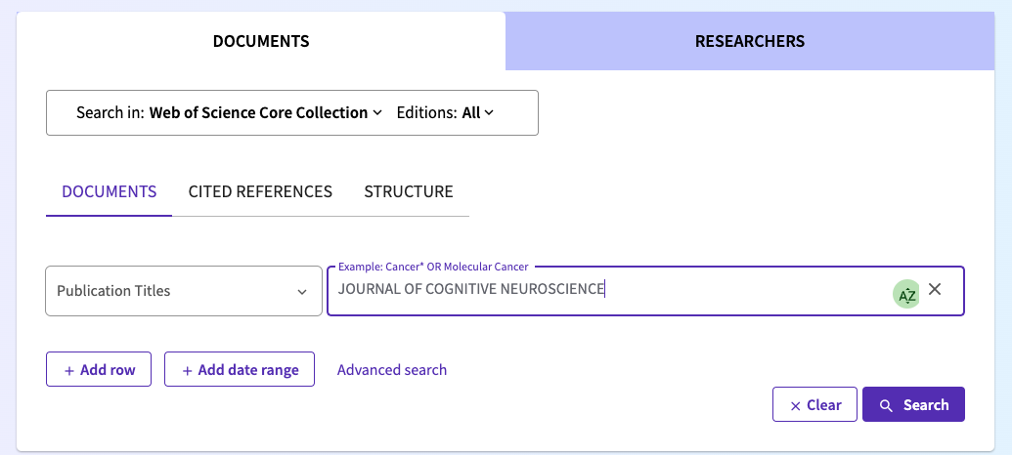

1. After hitting search, you should get a results page of items published in the journal. If you scroll a bit, you’ll see options to filter by Document Types on the left panel. Click the types you wish to download metadata for (we downloaded Article and Review Article).

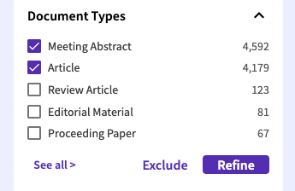

1. To download the filtered data by article type, click ‘Export’ and then export in the file format best suited for your needs. (Recommend using Plain Text File format).

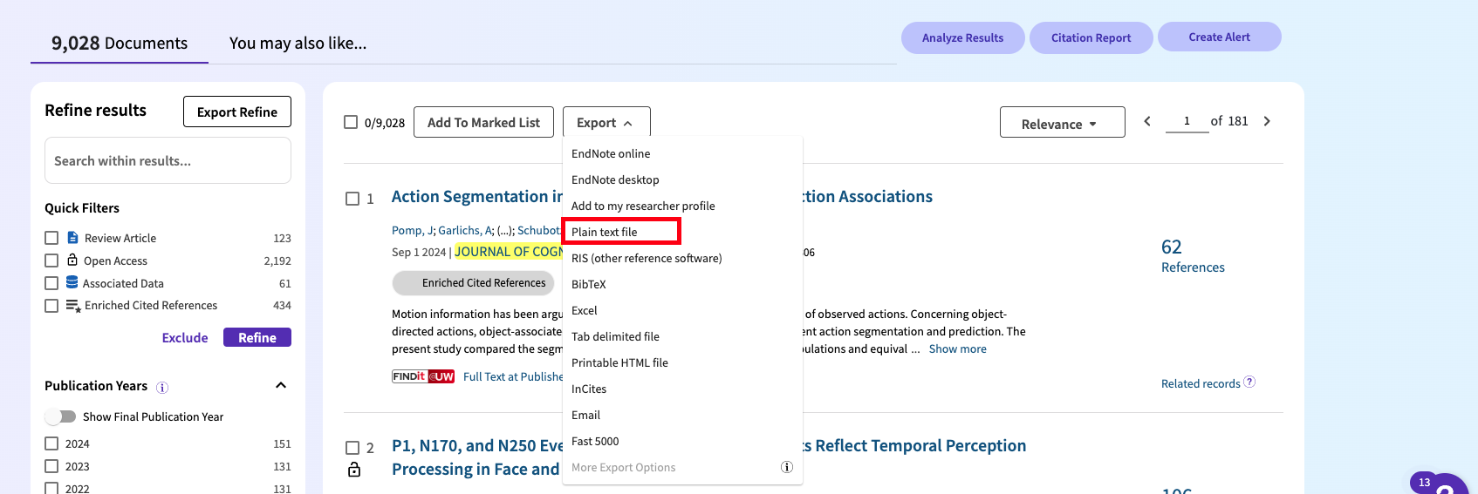

1. Then, proceed with downloading in batches of 1000 at a time (that’s the max that can be downloaded at once, and select the record type (i.e., the specific data you want to download).

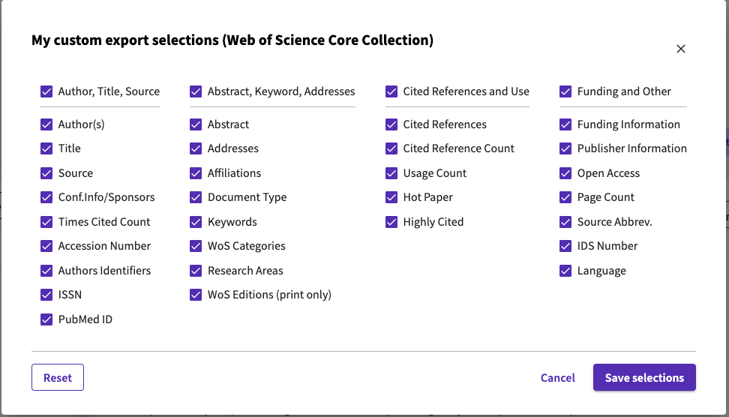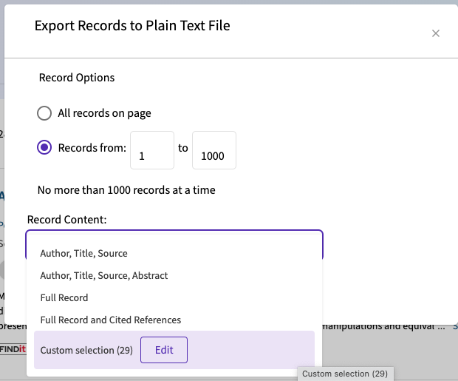

It is recommended to keep the same Publication Titles downloads in one file and label them as Publication Titles for ease of use in the next step.